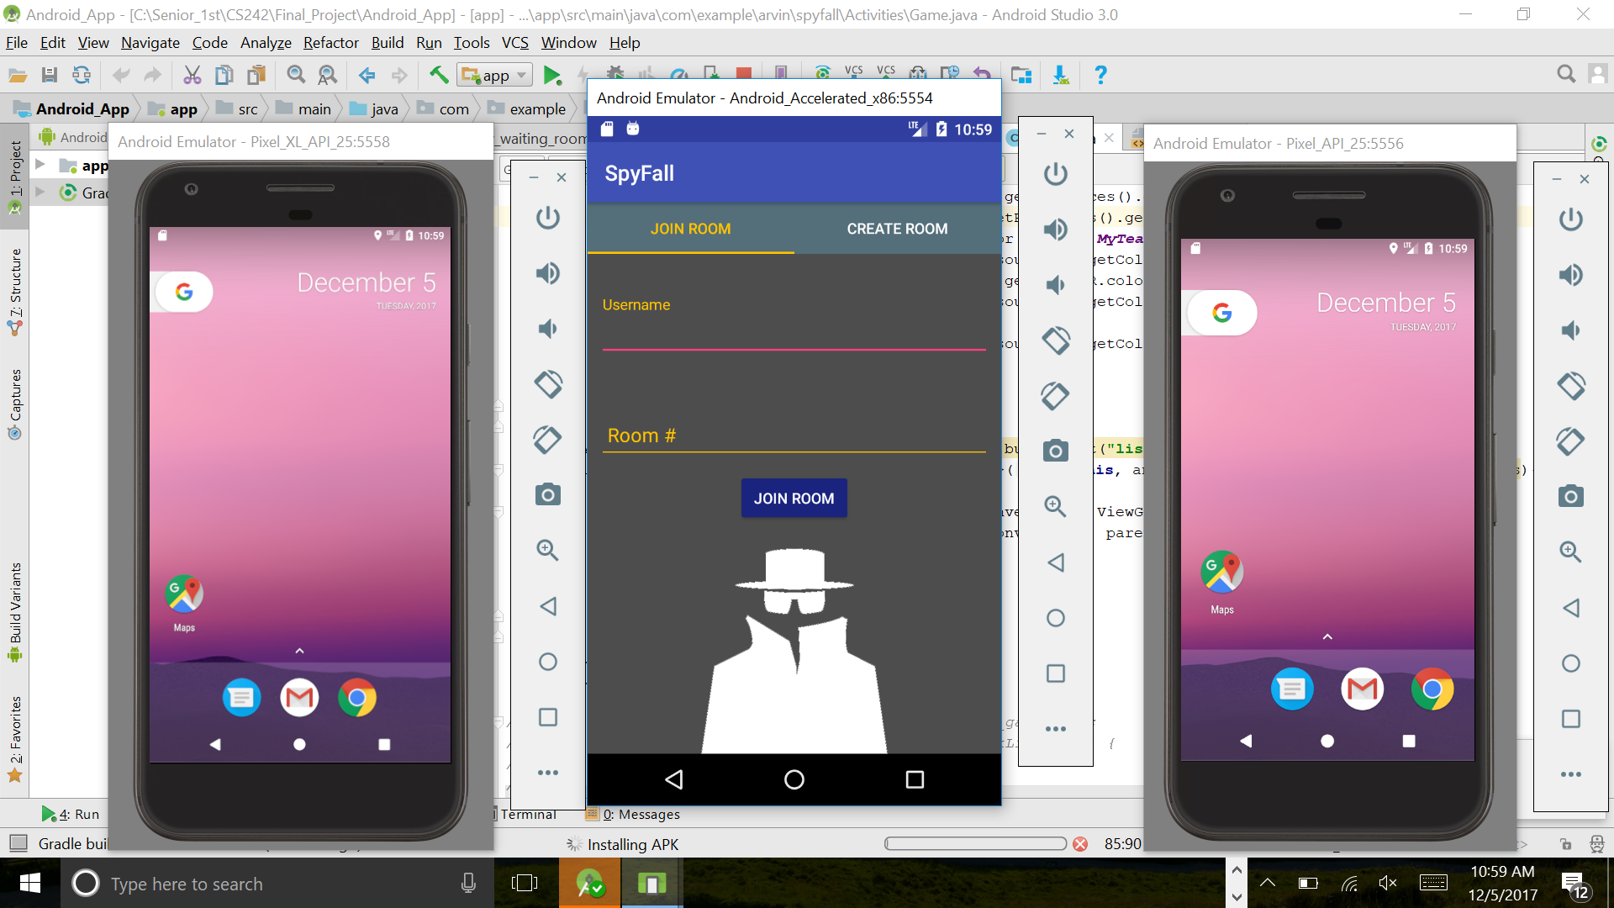 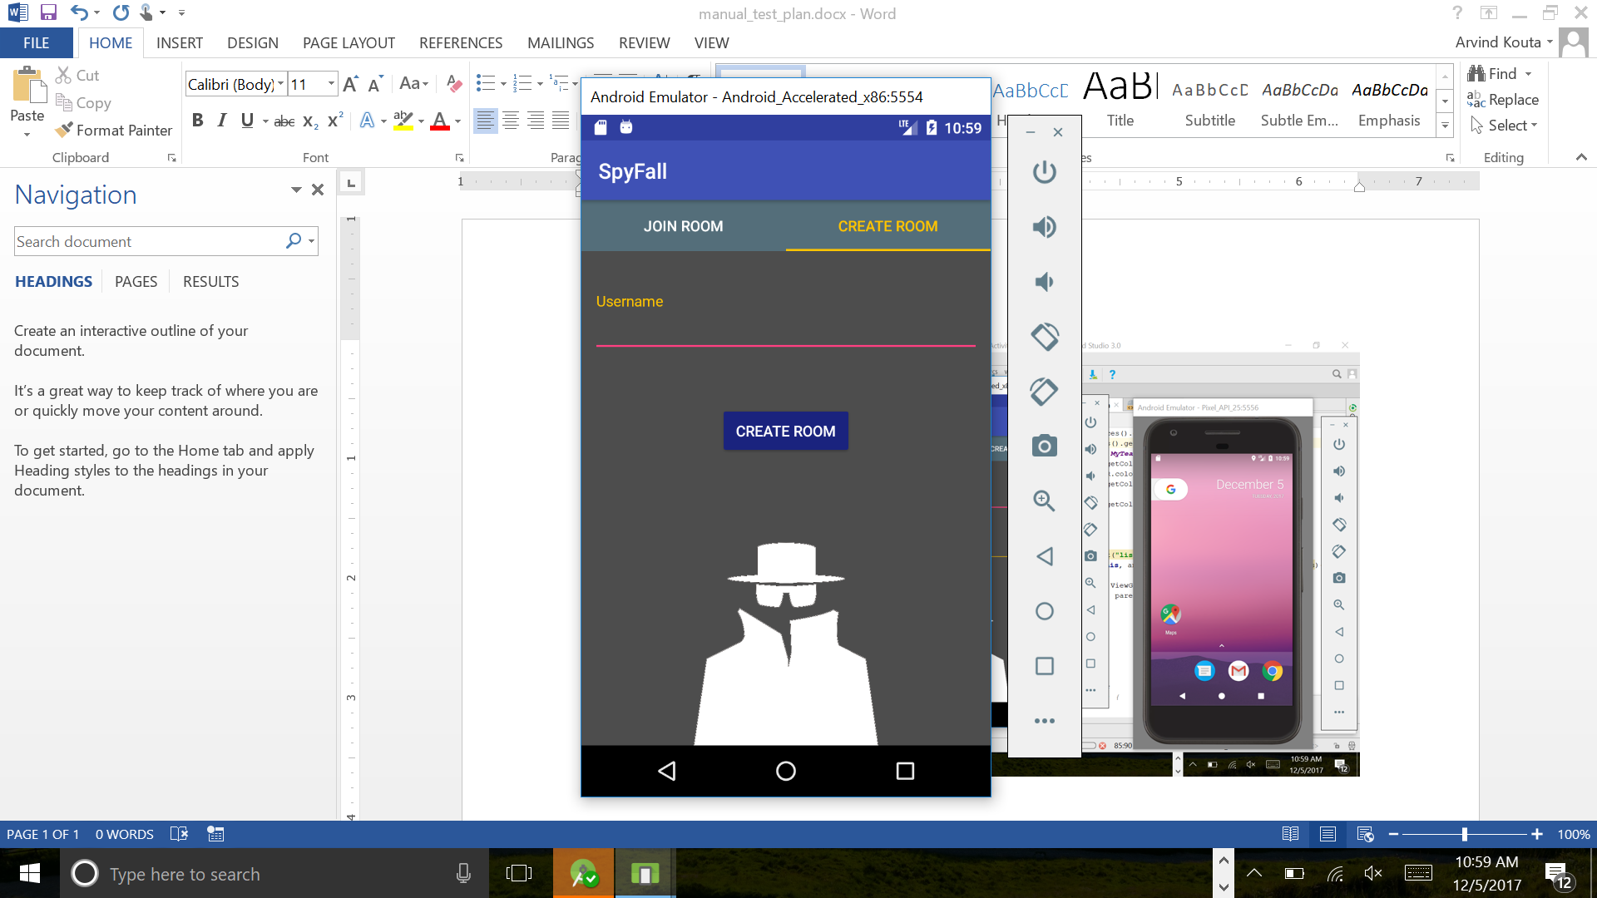

This is the home screen of the app. From here a user is able to join a room or create a room for other people to join.

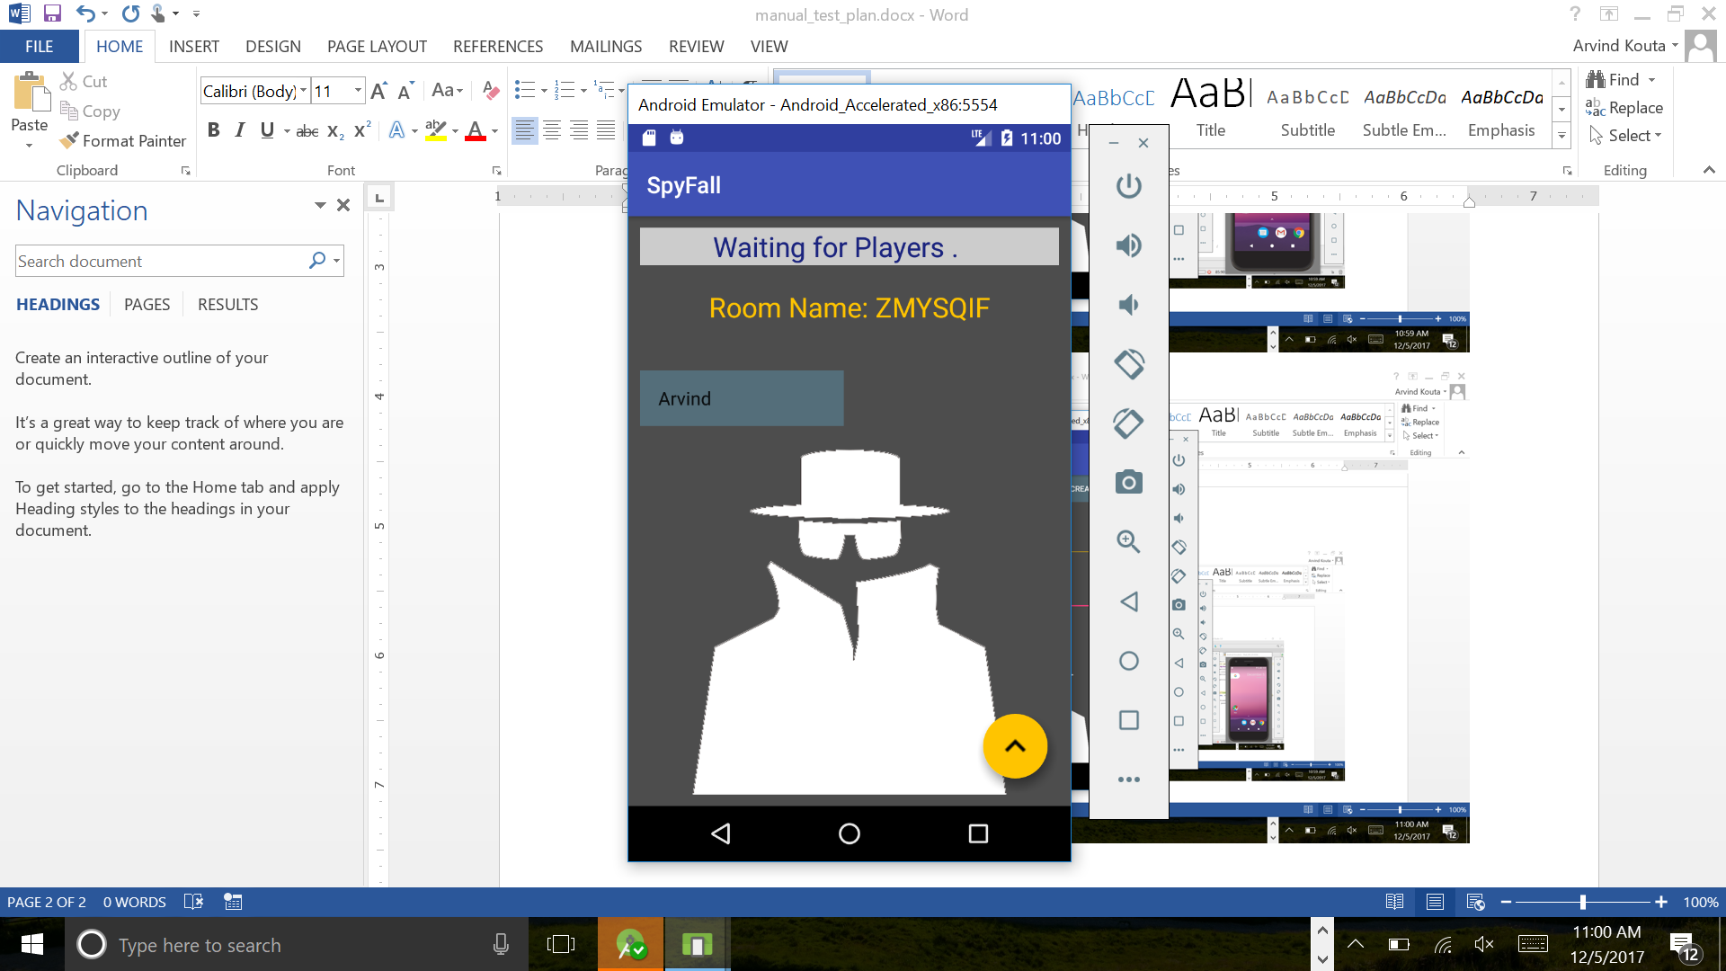

When a user joins or creates a room, he will be taken to a waiting room. You must provide a username in order to join or create a room. You also need an existing room name to join a room

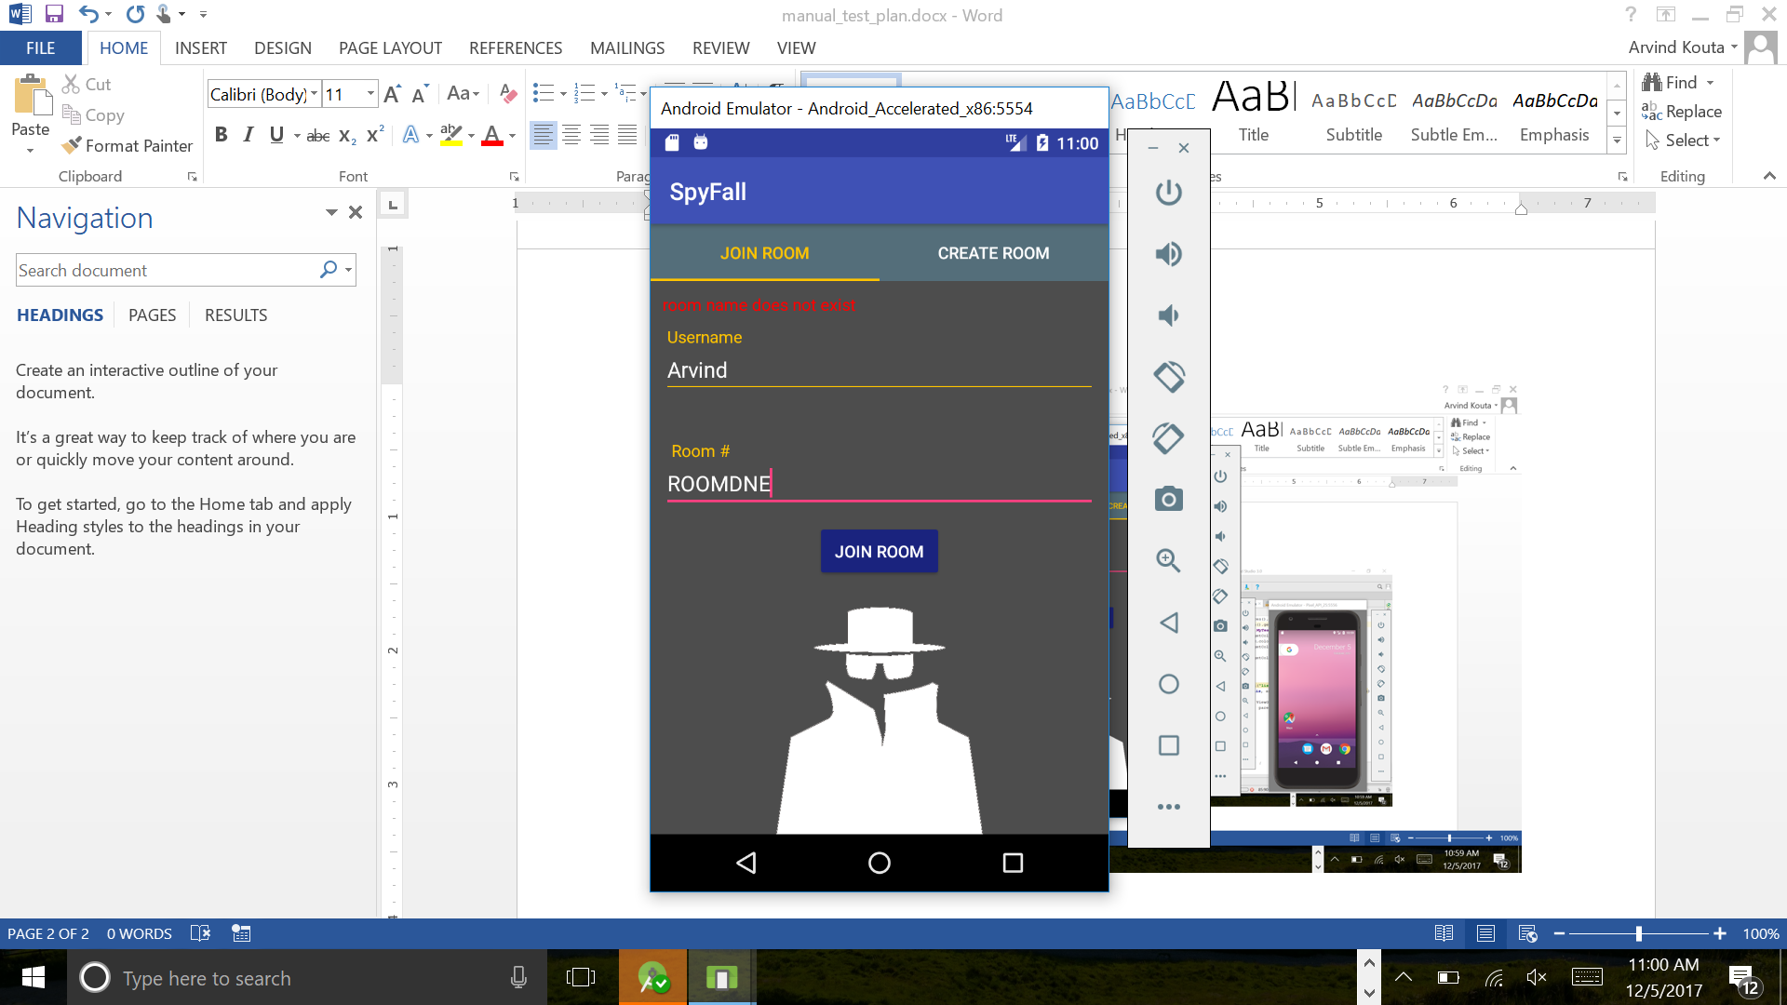 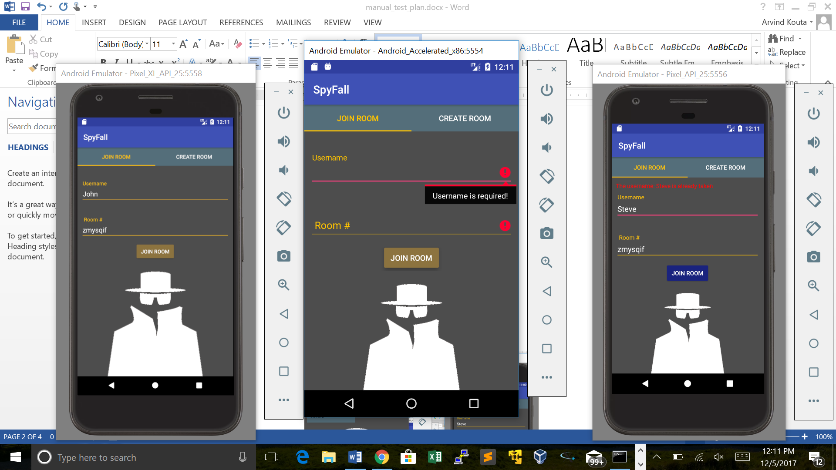

You will receive errors for not filling out mandatory fields

You will receive an error if you try to join a room that does not exist.

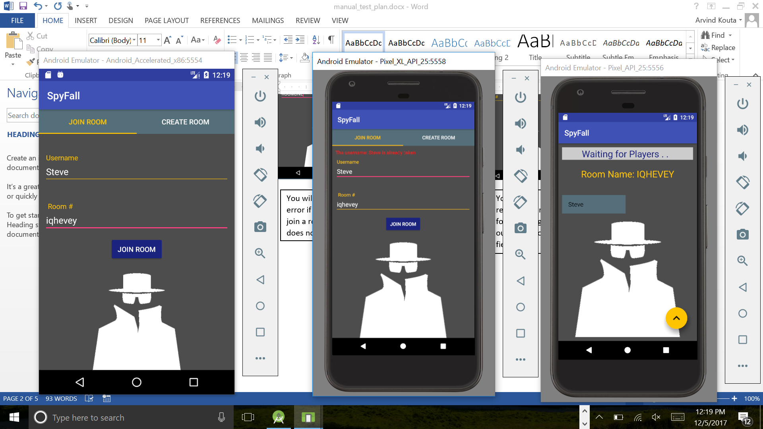

You will receive an error if you try to use the same username as someone that is already in a room

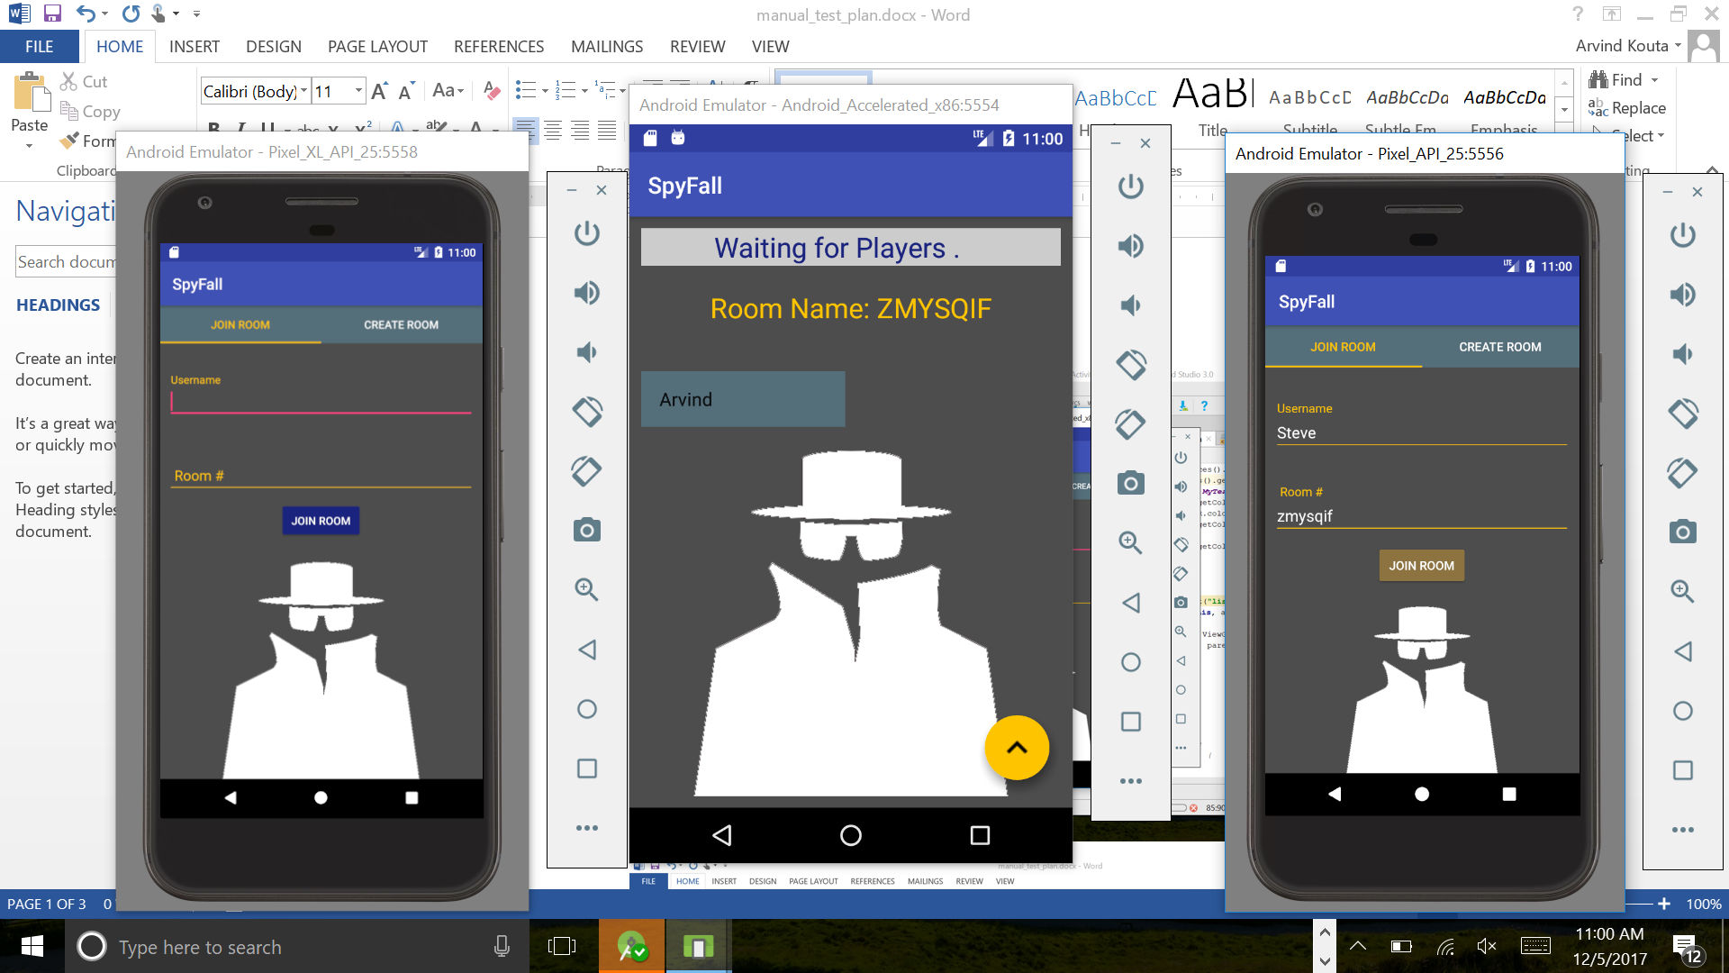

When joining a room, all players in the room will get updated players lists with all members in the room

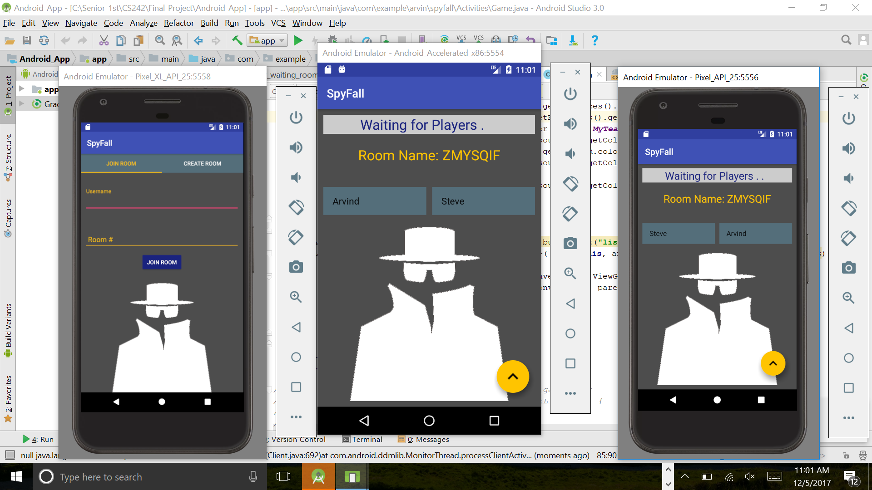

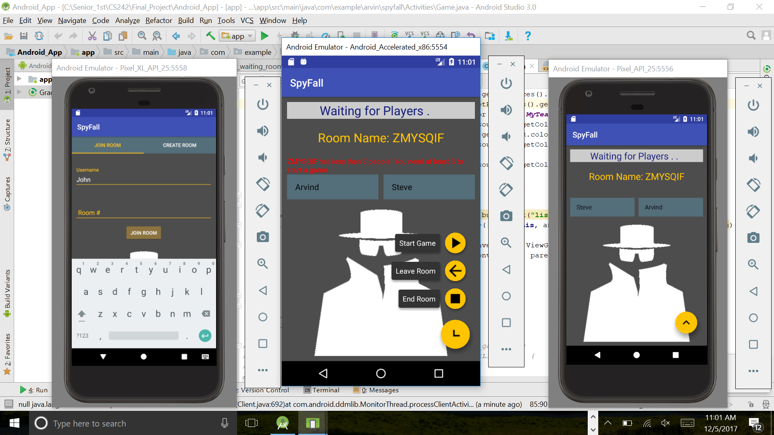

You will receive an error for trying to start a game when there is less than 3 people in the room

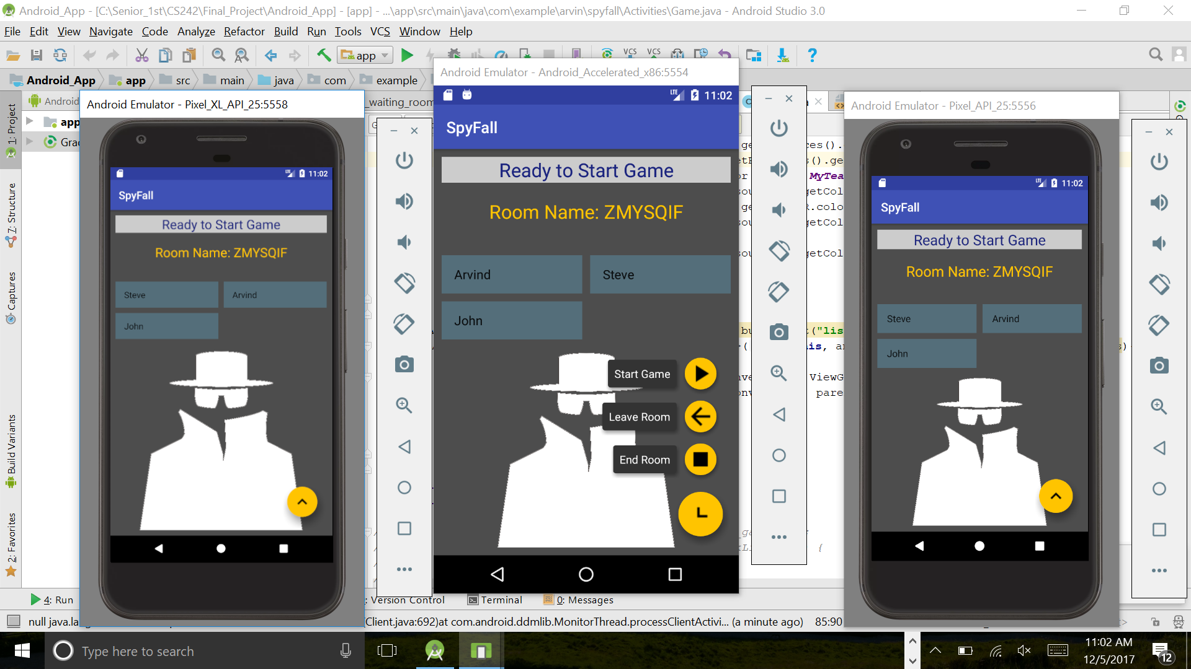

A user may leave the room and go back to the home screen or end the room for everyone and have everyone go back to the home screen at any time

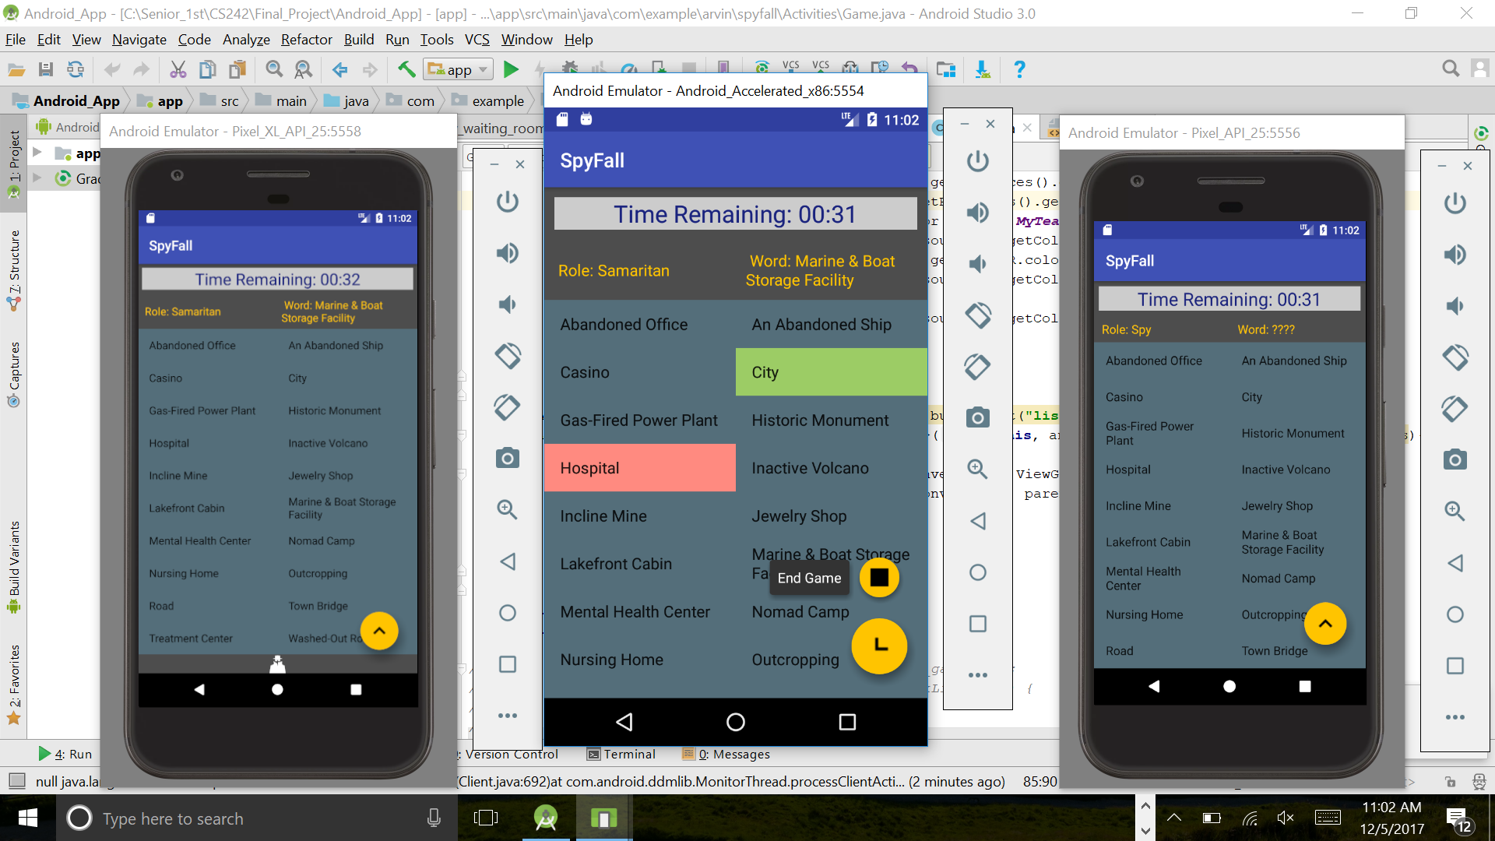

A user can end the game for everyone at any given time.

When there is at least 3 players in a room, the top TextView will indicate that a game can be played now. When clicking the Start Game button, you will be taken to the game activity and the game will begin. On the game activity, you will see your role, the word, and will be able to label words with either a blue, red or green color.

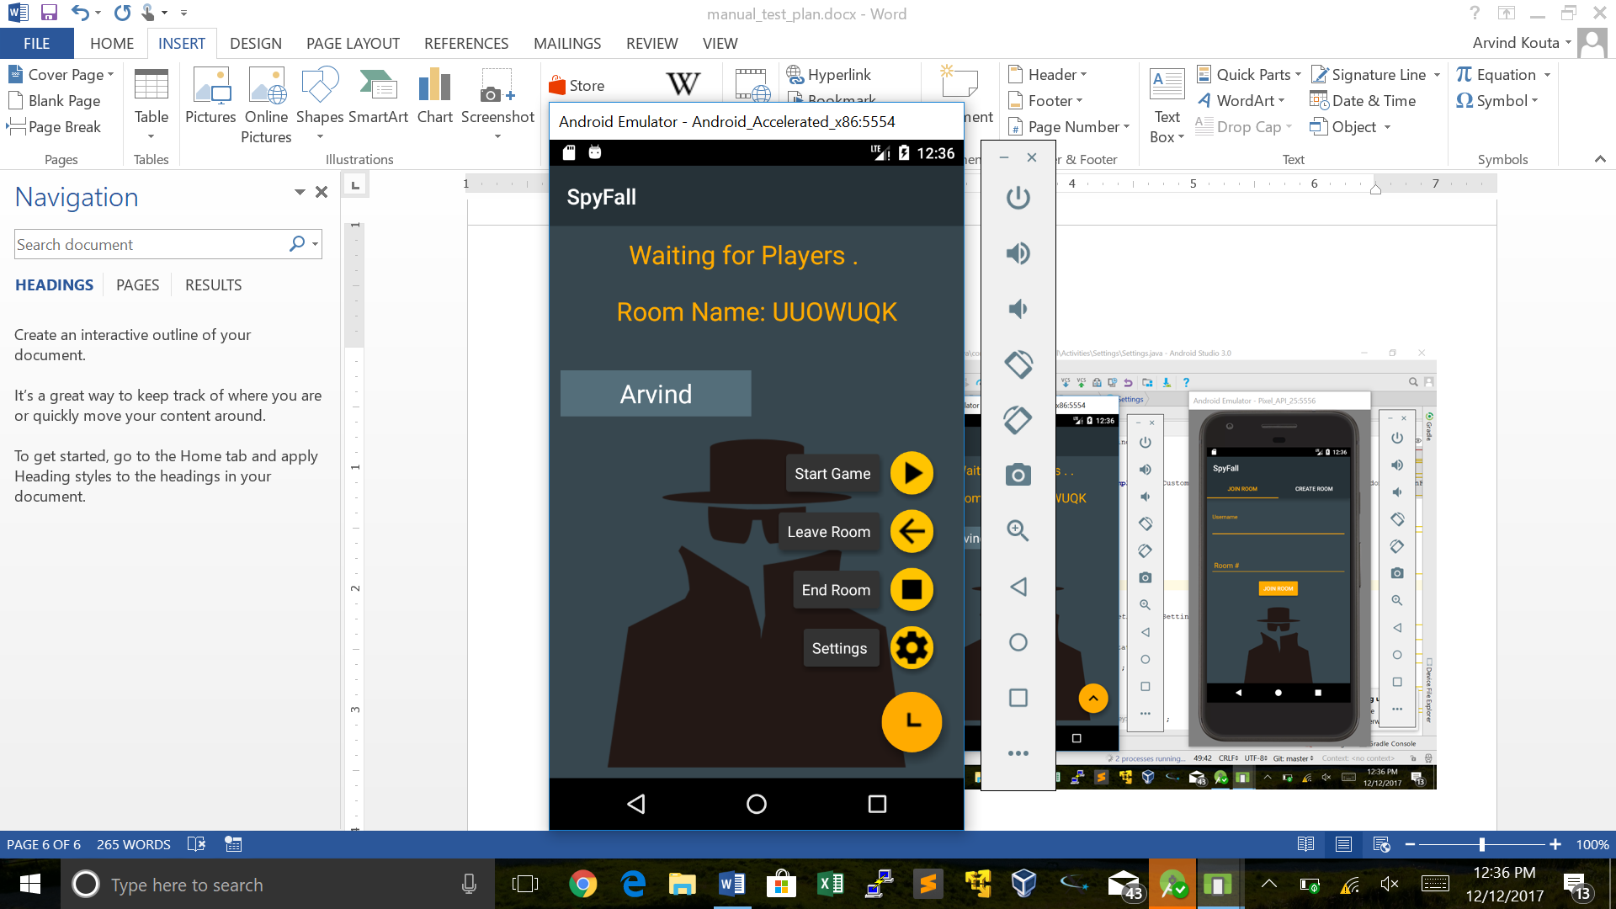

In the waiting room, a user can set the settings for the game and click the save button to save the new settings or cancel to restore the original settings and return back to the waiting room

